# WEB PROGRAMMING REPORT

**Students**

**ANIRUDH OPPILIAPPAN : RA1711003010715**

**GARVIT JHAWAR : RA1711003011090**

**JAI SAHNI : RA1711003011094**

**Q1 Create a Static Home Page by using HTML Tags and forms**

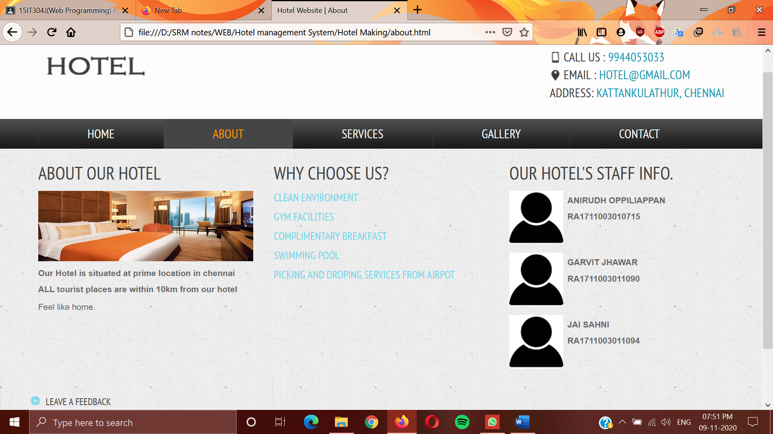

**Q2. Design a web page with an attractive background colour, text colour, an Image, font etc. (use internal CSS) 11-Aug-2020**

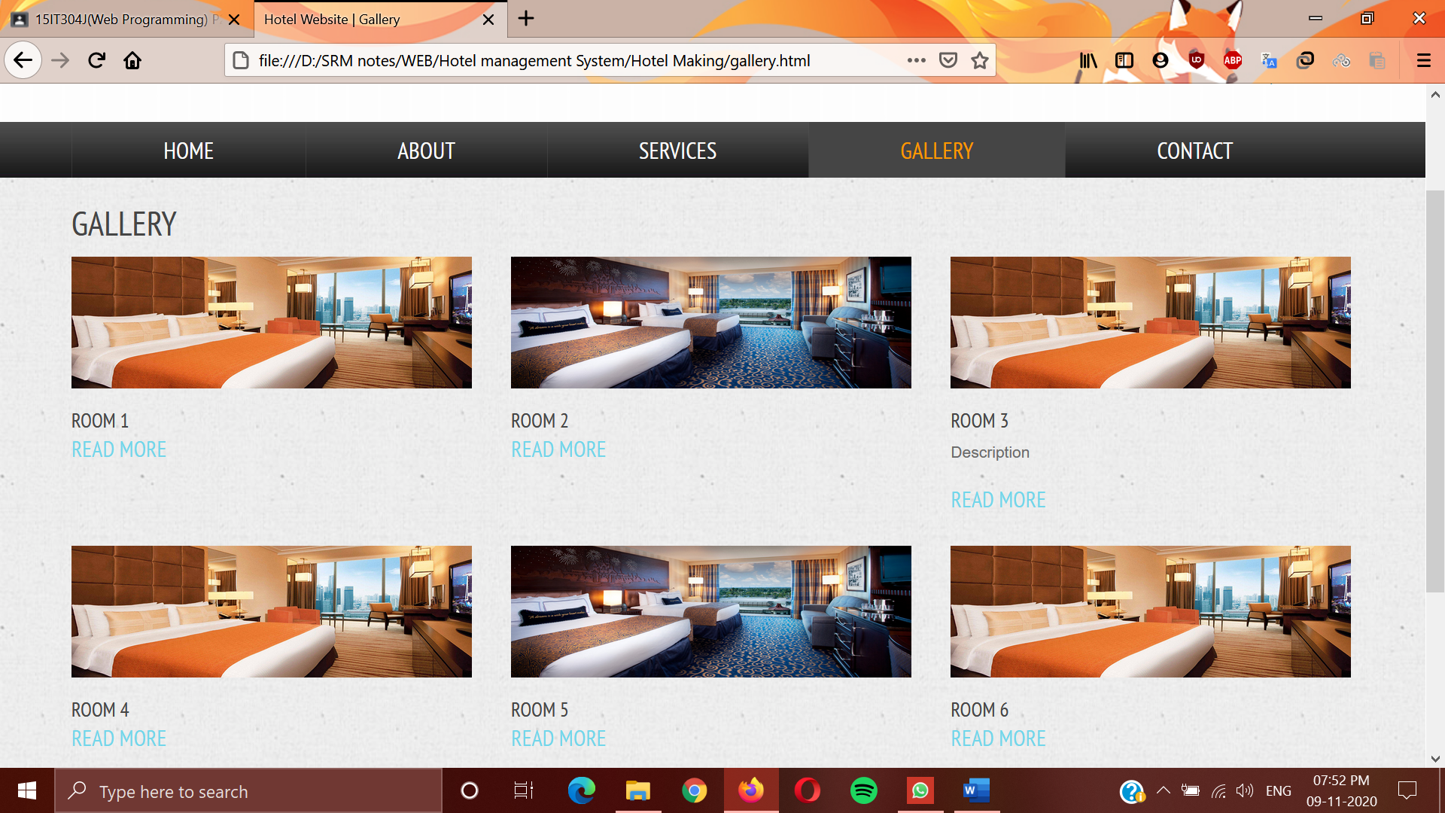

**Q3. Validate the Registration, user login, user profile pages using JavaScript**

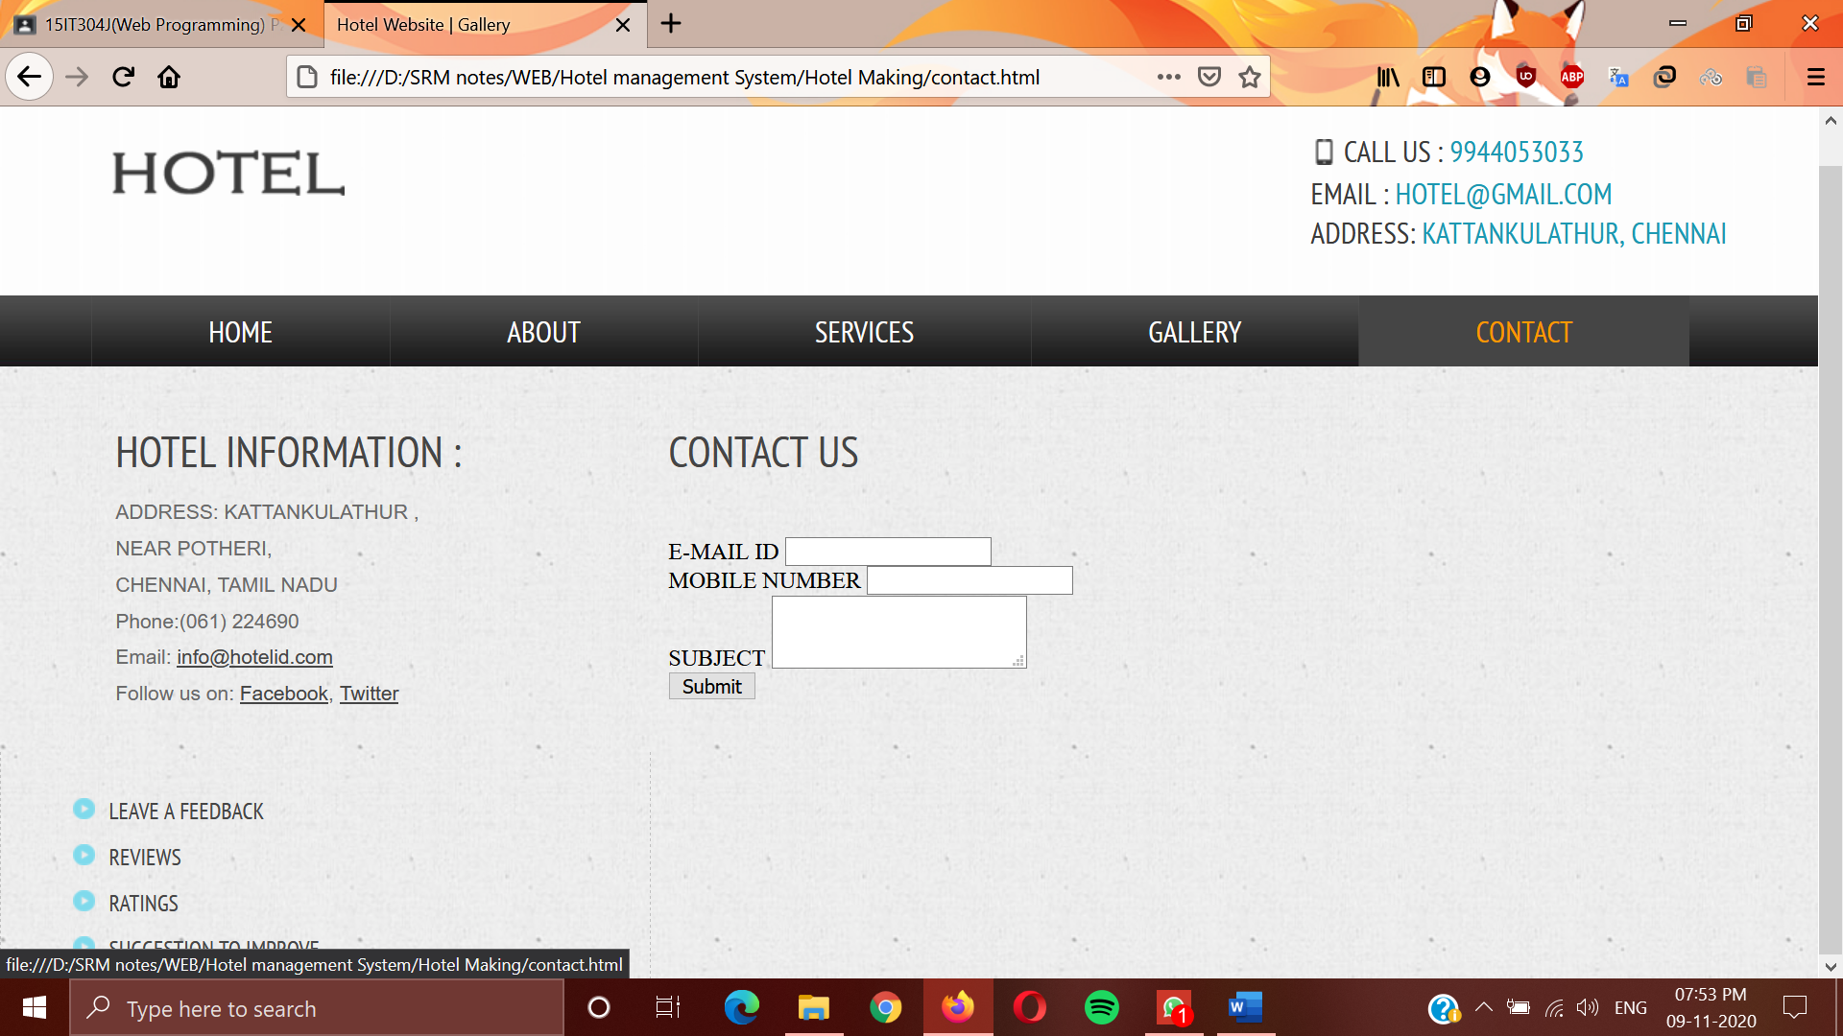

**Q4. Write an XML file which will display the information**

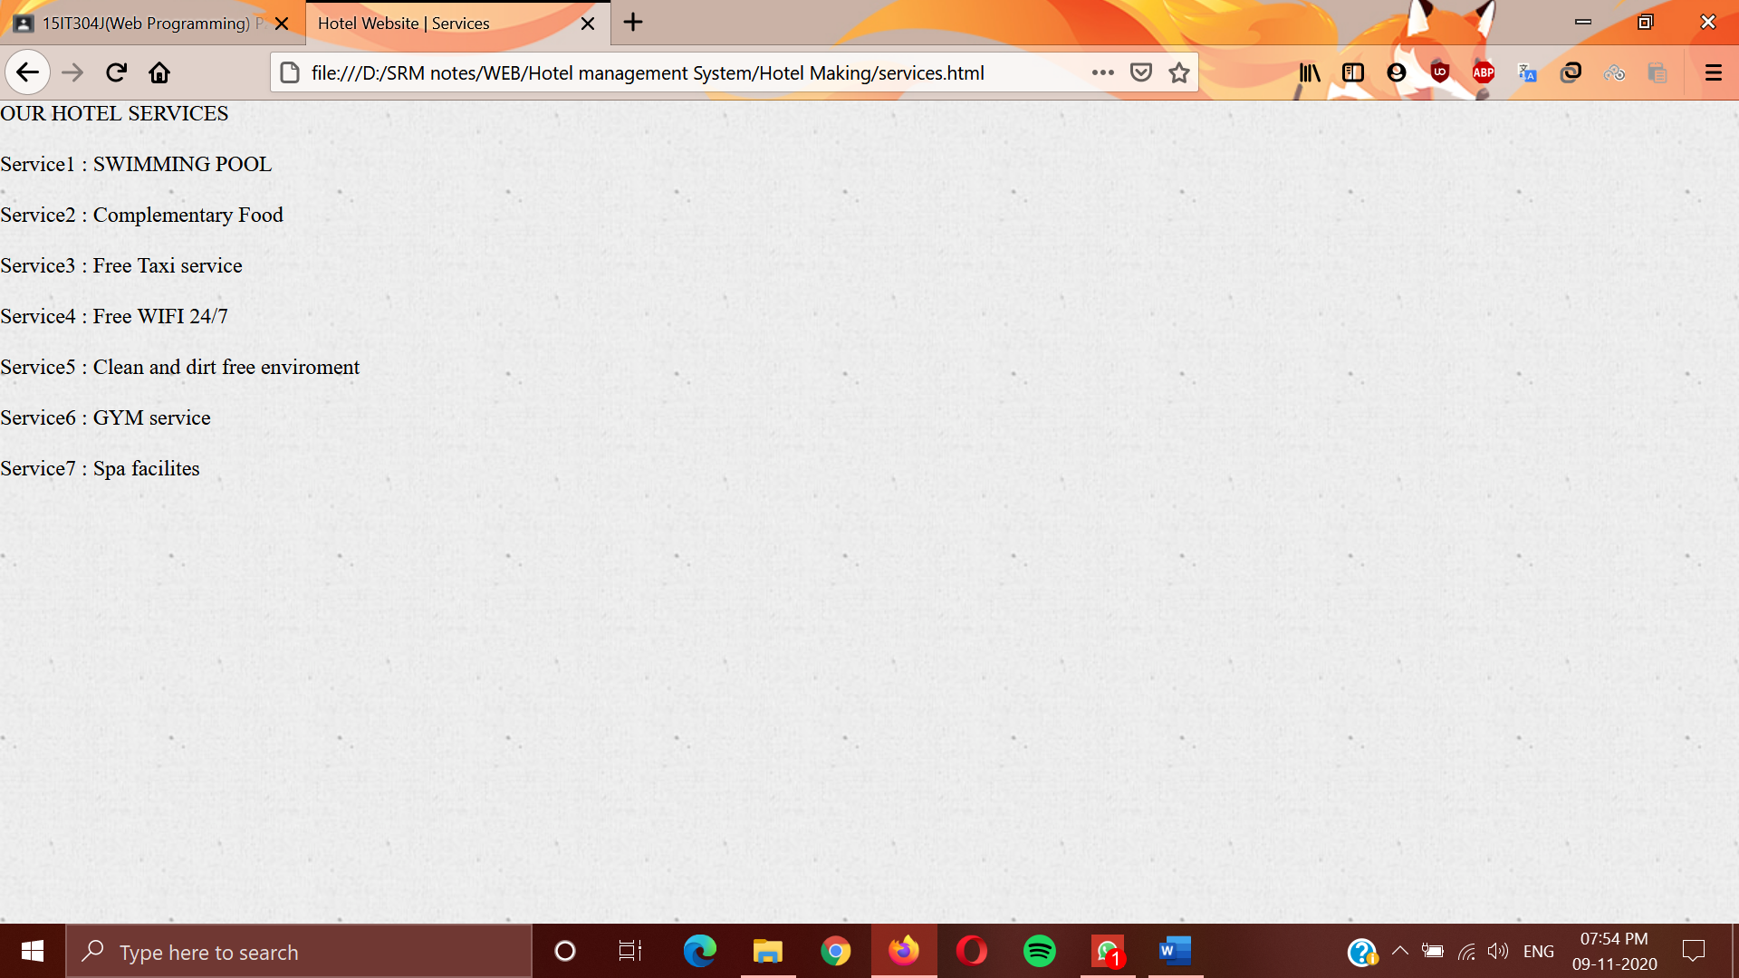

**Q5. Write a PHP Script for login authentication. Design an html form which takes username and password from user and validate against stored username and password in file**

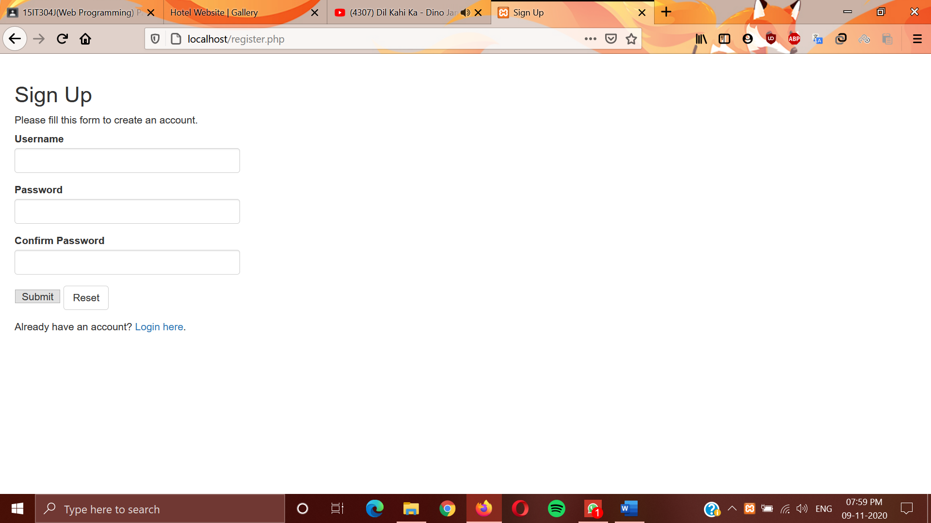

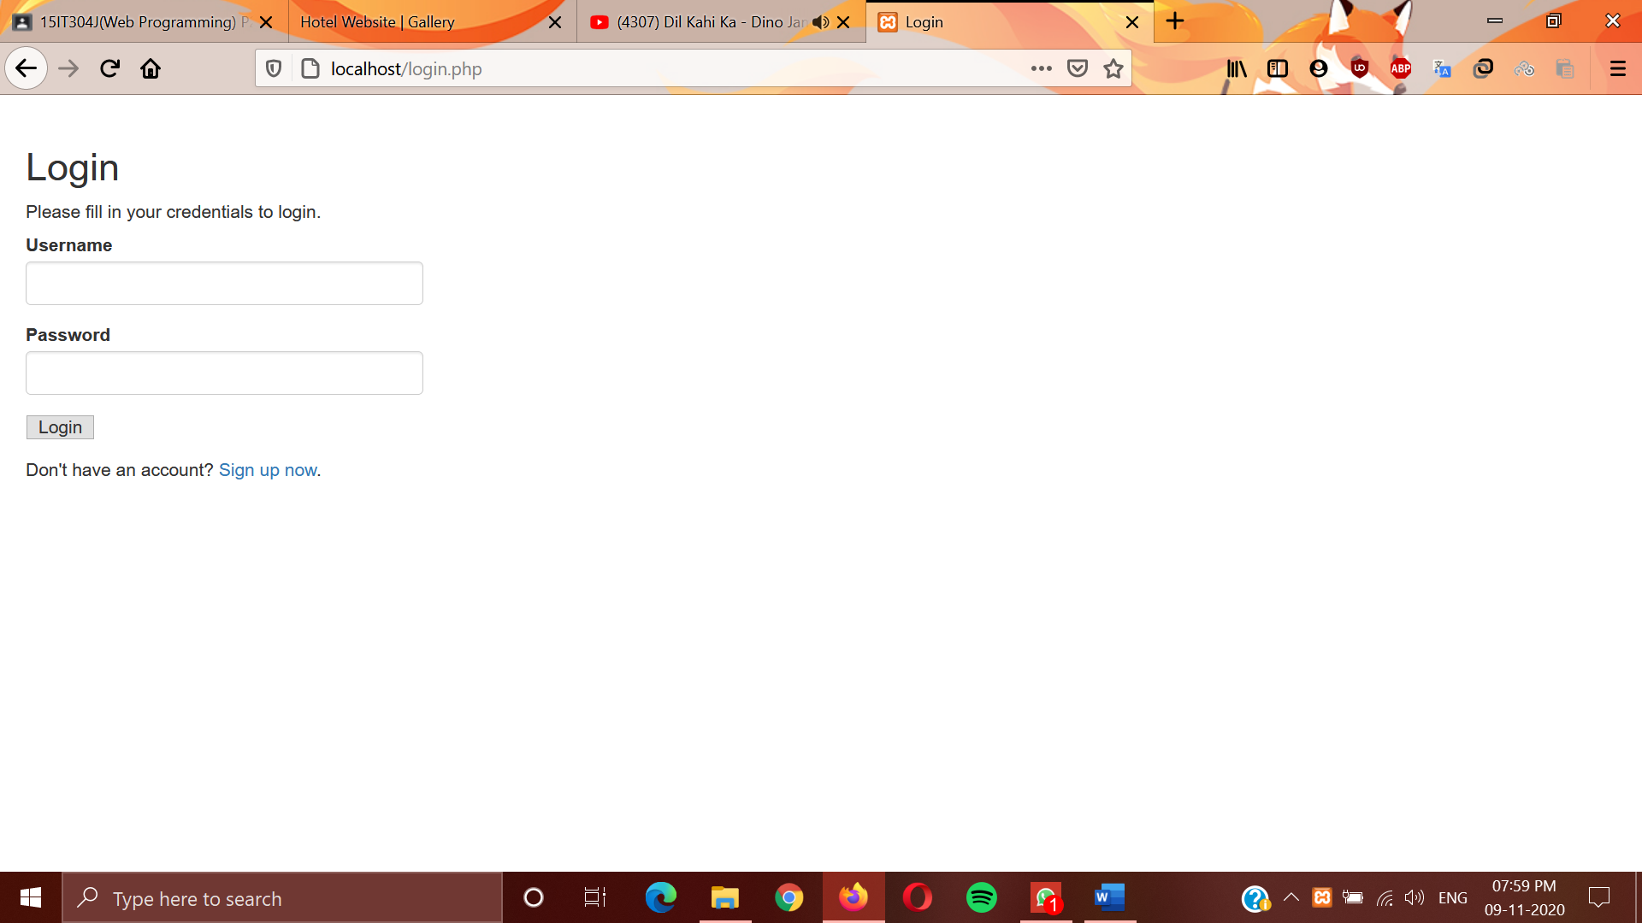

**Q6. Design a dynamic web page with validation using JavaScript**

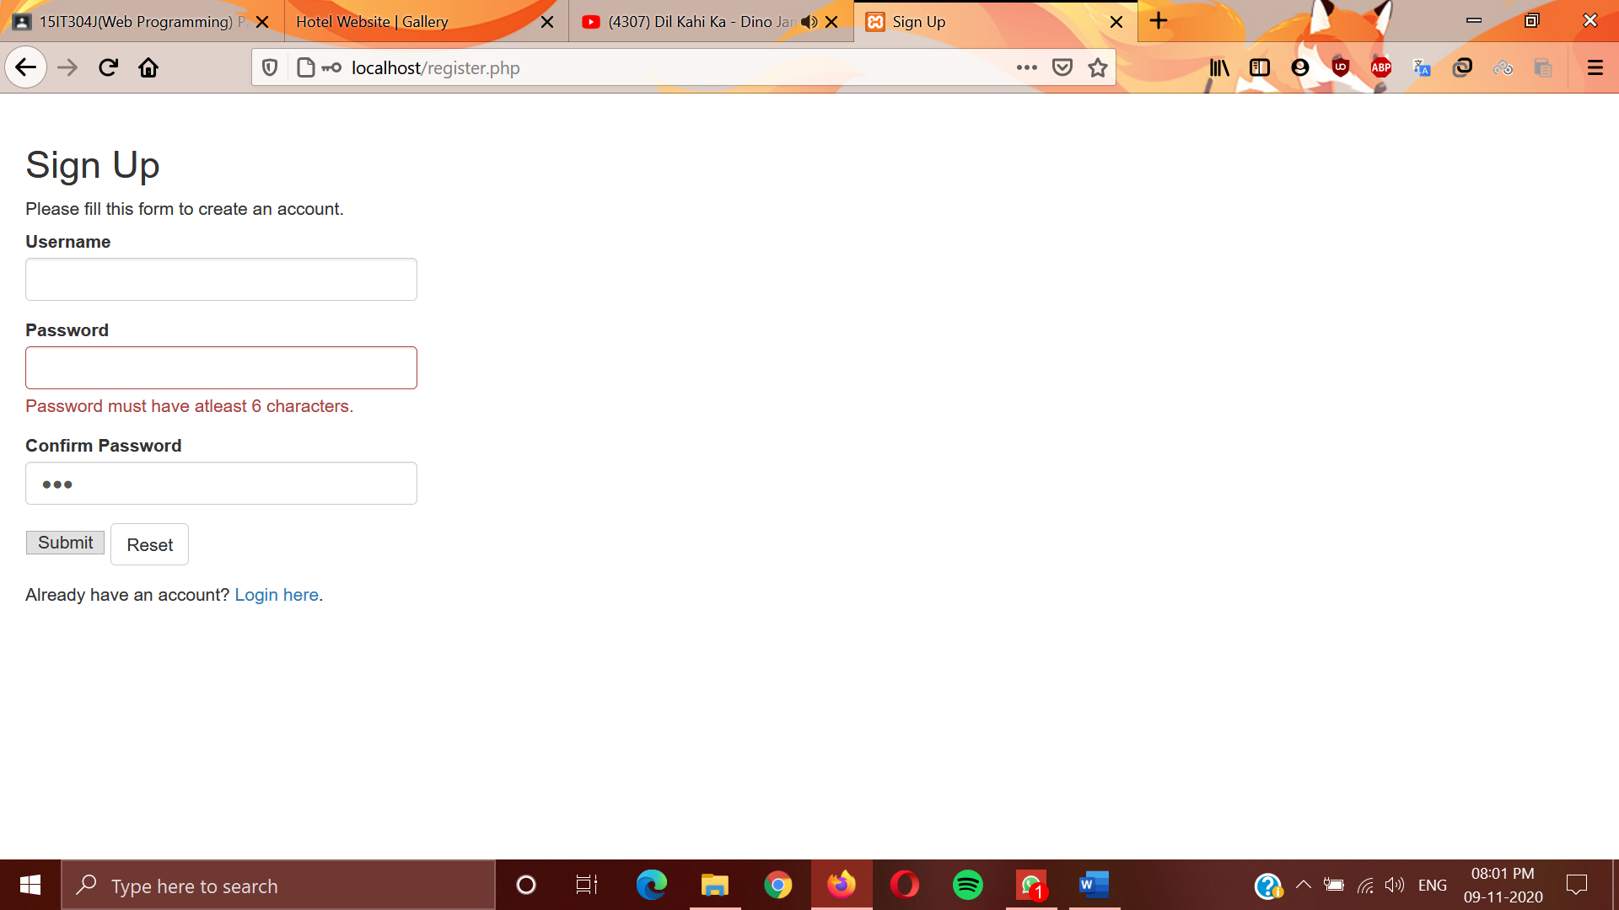

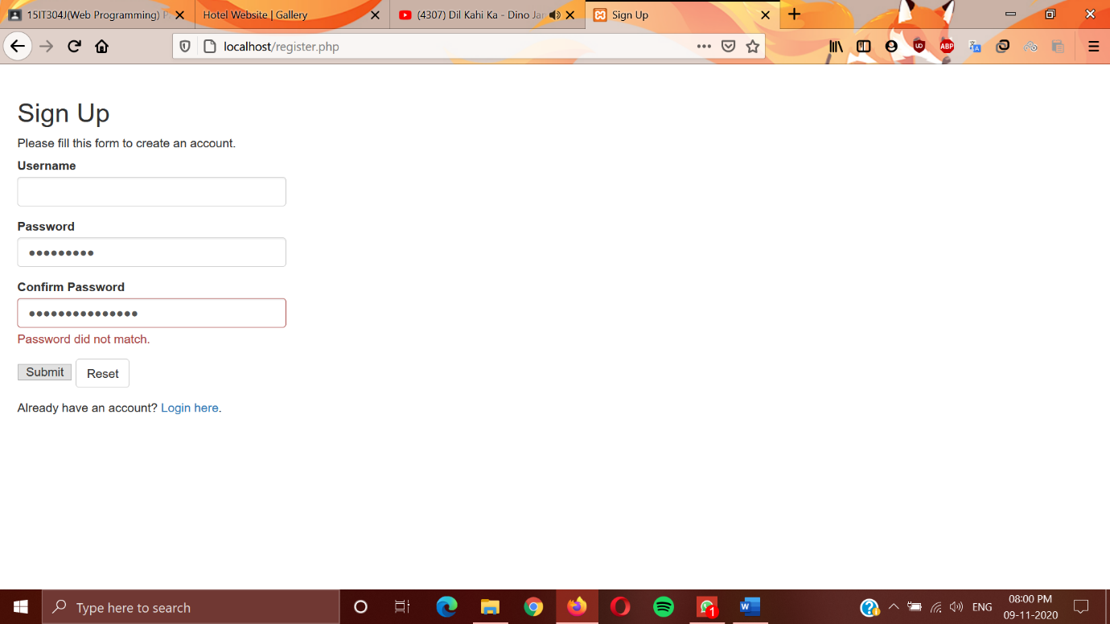

**Q7. Simple applications to demonstrate Servlets**

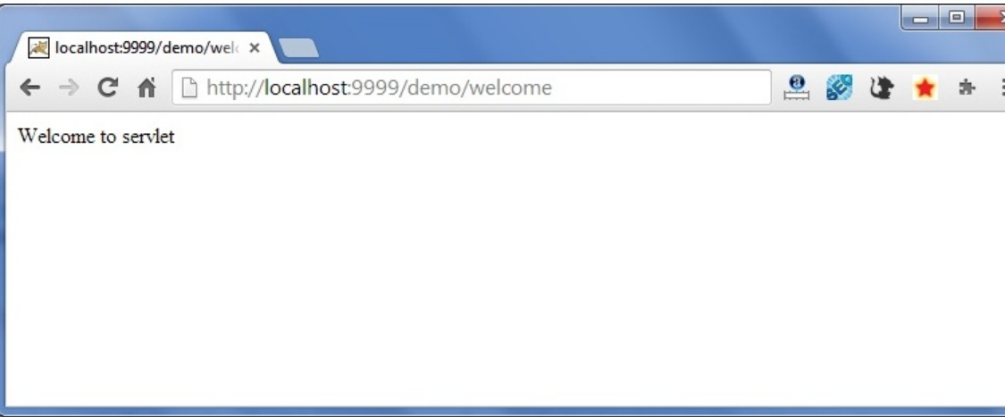

**Q8. Simple applications using JSP and AJAX**



**Q9. Design a simple online test web page in PHP**

